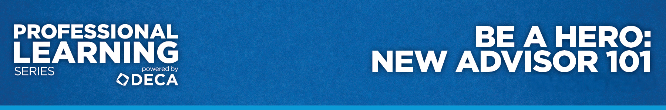

EVALUATION
“Be A Hero: New Advisor 101”

Directions: On a scale from 1-5, please rate the following statements (1-lowest and 5-highest).

- As a result of this workshop, I have a stronger understanding of DECA’s organization, mission and guiding principles.

1 2 3 4 5

- As a result of this workshop, I have a stronger understanding of my responsibilities as a DECA advisor.

1 2 3 4 5

- As a result of this workshop, I have a stronger understanding of how to manage my chapter.

1 2 3 4 5

- As a result of this workshop, I have a stronger understanding of how to implement DECA’s programs to enhance teaching and learning.

1 2 3 4 5

