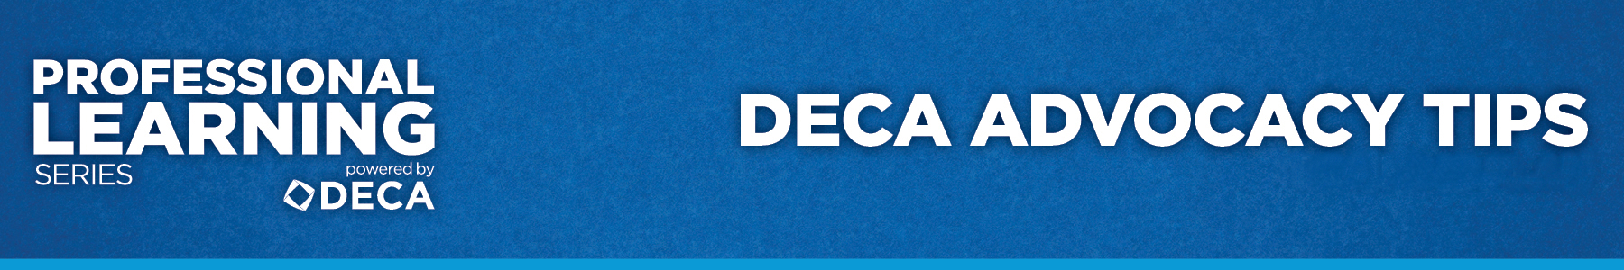

EVALUATION
“DECA Advocacy Tips”

Directions: On a scale from 1-5, please rate the following statements (1-lowest and 5-highest).

- As a result of this workshop, I have a better understanding of advocacy.

1 2 3 4 5

2. As a result of this workshop, I understand why advocating DECA’s educational value is important to the well being of my chapter.

1 2 3 4 5

2. As a result of this workshop, I gathered new ideas to be a better advocate for my DECA chapter.

1 2 3 4 5

3. As a result of this workshop, I have a better understanding of why sharing DECA’s story to specific audiences can benefit my chapter.

1 2 3 4 5

4. As a result of this workshop I am able to work with my students to help them become better advocates for DECA.

1 2 3 4 5

5. As a result of this workshop, I feel more confident to implement an ongoing advocacy plan of action for my DECA program.

1 2 3 4 5

