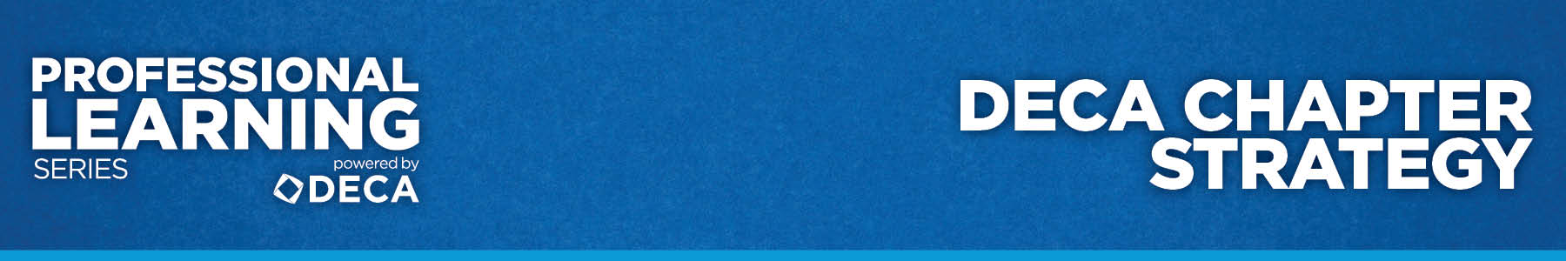

EVALUATION
DECA Chapter Strategy

Directions: Please darken a circle to indicate your level of agreement with the following statements.

As a result of participating in the “DECA Chapter Strategy” workshop, I have a stronger understanding of:

 | Strongly Disagree | Moderately Disagree | Neutral | Moderately Agree | Strongly Agree
1. DECA’s mission-based leadership roles. | ○ | ○ | ○ | ○ | ○
2. DECA’s Leadership Styles Inventory. | ○ | ○ | ○ | ○ | ○
3. DECA Goals planning tool. | ○ | ○ | ○ | ○ | ○
4. DECA’s Program of Leadership | ○ | ○ | ○ | ○ | ○
5. New ideas to enhance my DECA chapter’s strategy. | ○ | ○ | ○ | ○ | ○

