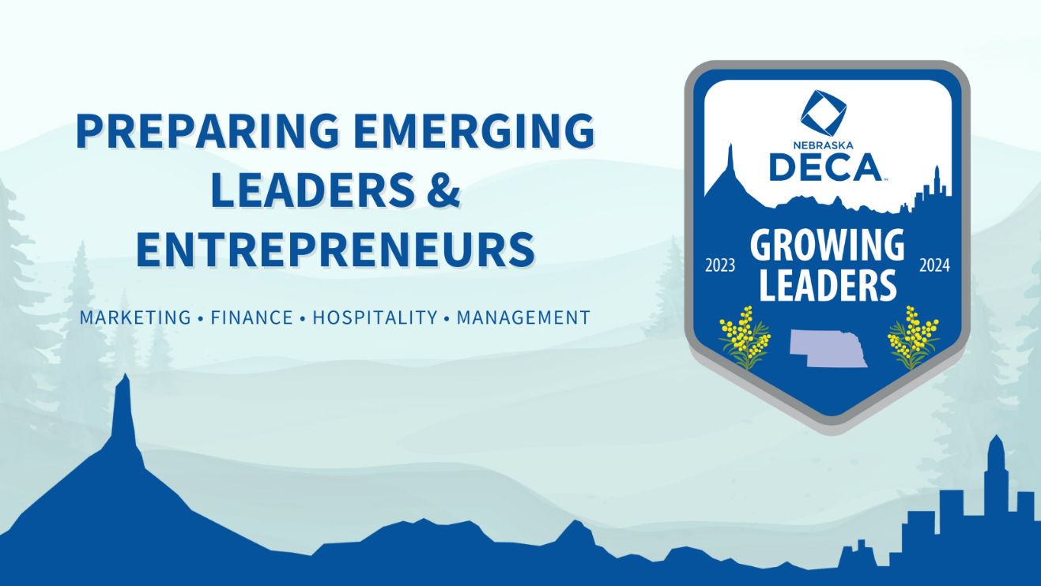

Nebraska DECA
Fall Leadership Conference
Hosted by Creighton Heider College of Business
at the Harper Center
Wednesday, October 11th, 2023
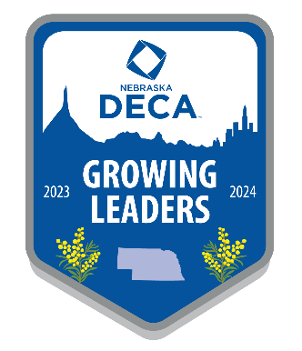
Fall Leadership Conference
Hosted by Creighton Heider College of Business at the Harper Center
602 N 20th St, Omaha, NE 68178
Wednesday, October 11, 2023

Register for an action-packed day that will:
⮚ Motivate your new members
⮚ Train and focus your officers
⮚ Growing Leaders is this year’s theme and this conference will give you and your members the tools to plan your plant the seeds of success within your program of work for 2023-2024!
What does the conference offer?
⮚ DECA-related workshops presented by the State Officer Action Team on ways to get the most out of every year of membership.
⮚ Business/Industry professionals who will present information about potential career paths and help students prepare for college and the workforce.
⮚AdVenture Morning Track sponsored by the American Advertising Federation (AAF) of Nebraska. This track will go from 10am- 1155 am. Students will be divided into small groups and tasked with creating an ad strategy for Runza. AAF professionals will help and guide students as they are working and then present to Runza’s representatives, maybe even a chance to try some new Runza products. This is a great option for students that are interested in advertising, leaders in your chapter or have attended FLC before, limited space. This will be limited to 70 student participants.
Registration for the AdVenture track will be on cut off at 70 students. Spaces will be held on a first come first serve basis, however please consider only registering 5-10 members of your chapter attending, to allow for other chapters to attend as well.

⮚ Keynote Speaker and workshop presenter, Dan Meers. Dan Meers has been KC Wolf, the mascot of the Kansas City Chiefs, for more than 30 years. In 2006 he was selected as the first NFL mascot inducted into the Mascot Hall of Fame. Dan travels throughout the United States and the world entertaining thousands of people both in and out of costume. He has performed in over 40 states and 12 different countries. He is in high demand not only as a mascot but also as a humorous and motivational speaker to audiences of all ages. His enthusiasm, optimism and love for life are contagious and make Dan an inspiration to all those he meets. Be it young or old, executive or blue collar, his audiences walk away with a smile and a renewed spirit to live life to the fullest. Whether you’re a Kansas City Chiefs fan or not, you’ll enjoy Dan Meers as he shares his unique wit and wisdom about life.

⮚ Who should attend? Any DECA members, chapter leadership team members, prospective state officers, and chapter advisors.
Registration: $45.00 per person Lunch and all conference materials are included. Registration is required via Excel spreadsheet (attached). Paid DECA membership is also required of all attendees. Excel spreadsheet, membership roster and registration summary/invoice must be emailed to Joann Marquez joann.marquez@nebraska.gov no later than Friday, September 22, 2023.
**Double check name spellings and that all columns are filled out!

Payment:
Checks made out to Nebraska DECA

Due to Grafton by September 22, 2023. Please submit prompt payment, with copy of the registration summary form to:
Grafton & Associates, Attn: Denise Winters
5935 S. 56th Street, Suite A
Lincoln, NE 68516
Parking:
Creighton Heider College of Business at Harper Center has parking on the south side of the building for vans and smaller vehicles. Please indicate if you will need bus parking on your registration form. This is in a separate lot.

Fall Leadership Conference
Hosted by Creighton Heider College of Business at the Harper Center
Registration Summary/Invoice

Due Date: September 22, 2023

Chapter
Name:
Registration |  | # | Cost | Total
Students |  |  | X $45.00
Adventure Track Participants |  |  | No cost
Advisors |  |  | X $45.00
Subtotal: |  |  |  |  | 01-4580
Transportation Type:
Total Amount Due:

Email invoice to joann.marquez@nebraska.gov and mail invoice with payment by September 22, 2023 to:

Nebraska DECA Fall Leadership Conference
Grafton and Associates
5935 S. 56th Street, Suite A
Lincoln, NE 68516
Make checks payable to: NEBRASKA DECA. Please indicate the code 01-4580 on the memo line.

Nebraska DECA Fall Leadership Conference
Hosted by Creighton Heider College of Business at the Harper Center
602 N 20th St, Omaha NE 68178
Wednesday, Oct 11, 2023

Schedule At-A-Glance
Wednesday, October 11, 2023
8:00-8:30 Conference Registration / Exhibit Viewing

8:45-9:00 Opening Session

9:05-9:50 Keynote Presentation
10:00- 12:05 DECA Advisor Meeting
10:00-12:05 AdVenture Track
10:00-10:35 Workshop Rotation #1 (State Officer Workshops, Keynote Speaker workshop (this time only), Creighton professor workshops)
10:45-11:20 Workshop Rotation #2 (Workshops repeated)
11:30-12:05 Workshop Rotation #3 (Workshops repeated)
12:10-12:55 Lunch / Exhibit Viewing
1:05-1:40 Workshop Rotation #4
• Competition Prep-Taste of DECA
• Business/Industry Sessions
• Leadership Sessions
1:50-2:25 Workshop Rotation #5
• Competition Practice (Sessions repeated)
• Business/Industry Sessions
• Leadership Sessions

