67th Annual

State Career Development

Conference

March 14-15, 2024

Lincoln Marriott Cornhusker Hotel
Lincoln, NE

At a Glance Information

Registration website | https://decaregistration.com/NE
Registration cost per participant | $75
Hotel cost | $122 per room per night, $164 suite per room per night*does not include tax, make sure to submit tax exempt form to the Cornhusker
Registration deadline (registration, registration cost, hotel list, written projects) | February 5th, 2024
Written projects deadline | February 5th, 2024 in one PDF via email to mary.janssen@nebraska.gov and maggie.schneider@nebraska.gov
Payment | Registration payment and invoice is due to GRAFTON and Associates by February 5th, 2024. Please plan and communicate with us if it takes a little longer for payment to be sent. We get it, we just need to know your timeline. Include the budget code 03-4580 on your check and invoice.  Hotel invoice and payment is due to Heather Long at The Cornhusker by March 4th. She will automatically get your rooming lists sent to her through the registration site.  Invoices will be generated automatically through the registration site. Print these out and include them with payment.
DECA Inc. Registration site | Your students MUST be registered members in order to register them for State. This is pulled directly from the DECA membership site. https://membership.decaregistration.com/deca#

Information you will need to gather from your students:

- Event(s) they are competing in
- Who they are rooming with
- T-Shirt Size
- Code of conduct form (you keep this)
- Medical release form (you keep this, optional)
- Any other permission form you may want or require from them from your local school or district
- Any potential conflicts that they know of for competition scheduling. (email this directly to Mary Janssen mary.janssen@nebraska.gov and maggie.schneider@nebraska.gov)

State Conference Registration and Lodging

Online registration
We have a new online registration system this year through DLG! DLG also manages the testing site. https://decaregistration.com/NE

Most information will now be submitted using an online site, rather than emailing forms. Invoices will be automatically generated through the site, so you will be able to print these and mail with payment.

There will be three office hours to help facilitate and answer any questions around registration. These are Tuesday, January 9th at 3:45 CST, Tuesday, January 23rd at 3:30 CST, and Thursday, February 1st at 3:30 CST. We can also schedule a meeting to go through the registration process individually if needed. Or just give us a call or email! We want this to go as smoothly as possible for you all!

Conference Registration
Please read through all of the registration materials paying special attention to due dates, costs, rules and guidelines for all aspects of the conference. This is later in the packet.

Registration, registration payment, hotel rooming lists, and written projects must be submitted no later than Monday, February 5, 2024 or will not be accepted! Hotel payment is due March 4th to the Lincoln Marriott Cornhusker Hotel.

You will use this link to register online.
https://decaregistration.com/NE

All written projects are to be submitted ELECTRONICALLY (PDF format). Presentation judging will occur on both Thursday and Friday. A detailed schedule will be sent out prior to the conference.
TEAM EVENT PARTICIPANTS WILL COMPETE IN TWO ROLE PLAYS – THURSDAY AND FRIDAY. No finals.

- Registration Fee
The registration fee for the State Conference is $75.00 per student and advisor. This fee includes:
- Registration and conference materials, t-shirts
- Dance and all other entertainment expenses
- Competitive event expenses, trophies, plaques, certificates, medallions, and other awards
CONFERENCE REGISTRATION INSTRUCTIONS
Registration must be submitted online by Monday, February 5, 2024 by 11:59 pm.. Once your registration is submitted, you will receive an invoice via email. Use this invoice to submit for payment from your district.

Registration site: https://decaregistration.com/NE

- Registration Invoice Payment – Will receive invoice after online registration, print and mail invoice along with payment (budget code 03-4580 on the subject line of the check) to Grafton & Associates, 5935 S. 56th Street, Suite A, Lincoln, NE 68516.
- Hotel information - Will be submitted in the online registration. You will receive a separate invoice that you will print out and include with hotel payment. Mail invoice and payment to the Cornhusker Hotel CC Heather Long 333 S 13th St, Lincoln, NE 68508 by March 4th.
- Scholarship Donation-Your chapter donations can be added to your overall invoice and registration. Choose the amount on the site from the options listed to add.
- Chapter Permission Form and Test Proctor Form–Will be submitted in the online registration. This is uploaded under “chapter forms.” It should be one PDF document.
- Judges Information Form – Email to Maggie and Mary - maggie.schneider@nebraska.gov and mary.janssen@nebraska.gov OR submit directly through the link https://forms.gle/eQzfAbatorCkfkVm9.
    - All chapters are asked to submit a minimum of 3 judges, more if possible.
- Chapter Photos – We will send out an email in late January, early February for chapter photos.
- Voting delegate-We will include the correct number of ribbons in your registration packet at state. You do not need to designate in advance. Based on the number of paid members in your chapter you are allowed a certain number of delegates:
0-20 Members = 3 Delegates
21-40 Members = 4 Delegates
41-60 Members = 5 Delegates
61-80 Members = 6 Delegates
81-100 Members = 7 Delegates
101-120 Members = 8 Delegates
121 + Members = 9 Delegates
Voting delegates must be able to attend all delegate sessions.
- Leadership on Parade-A “parade” of chapter officers will kick off our Grand Awards session on Friday night. Enter the first and last name of your representative and title in the registration site. He/She/They must also attend a rehearsal immediately following competitive events Thursday night.
- Written Projects – Email to Maggie and Mary - maggie.schneider@nebraska.gov and mary.janssen@nebraska.gov no later than February 5, 2024.
- **Written projects are to be submitted ELECTRONICALLY via email. Save each project as a PDF file, making sure that the signed written statement of assurances is added as the first page of each file. The file titles should be titled: Event Acronym, Chapter Abbreviation, Last Name Last Name Last Name.pdf, for example: CSP MS Collins Smith Wagner.pdf
Email to Maggie Schneider (maggie.schneider@nebraska.gov) and Mary Janssen (mary.janssen@nebraska.gov) no later than February 5, 2024.
**The only format accepted is PDF. The written statement of assurances needs to be the first page of the PDF document. Please let us know if you have any difficulties sending as an email attachment. Try to condense it so that files aren’t as large.

Hotel Room Reservations and Payment

Lodging is based on the date forms are received at the Cornhusker, DO NOT DELAY!
Lodging costs at the Cornhusker Marriott are as follows:
$ 122.00 single room
$ 122.00 double ($61 per person, per night)
$ 122.00 triple ($40.67 per person, per night)
$ 122.00 quad ($30.50 per person, per night)
$ 164.00 Suite
**You MUST provide the hotel with your tax exempt form, otherwise you will be charged an additional 16.74% tax.
  - You will use the rooming list template in the registration site to submit your room assignments to The Cornhusker. After completing your rooming list, you can print off the invoice from the registration site. Print off and mail the invoice with payment directly to the Lincoln Marriott Cornhusker Hotel. They will then block all the schools. Do not send hotel forms or payment to Nebraska DECA.

All registration and hotel forms are to be submitted by Monday, February 5, 2024 through the online site. Hotel payment must be submitted by March 5 to the hotel. Please contact the hotel directly with changes after February 5th.

Advisor to Student Ratio
The chaperone ratio for the State Career Development Conference is one adult per 16 student participants (1:16). Any questions relative to this ratio are to be directed to the State Advisor only. No student may attend the conference without his/her local advisor.

Additional sponsors for each school will be assigned to help run contests also. Please inform them of this in advance. The more adults we have, the better, so additional advisors above the 1:16 ratio, are not required to pay registration fee.

Student Eligibility
Students who are active or associate members of their respective Chapters are eligible to participate in the State Career Development Conference if they meet the following criteria no later than February 5, 2024 (registration due date):
- Registration fees are paid and their names submitted on the official registration forms to the State Advisor.
- State and International DECA dues and rosters have been submitted.
- Delegate conduct/procedures forms with all required signatures are completed and submitted to the chapter advisor.

The student will not show up on the registration site unless they have been submitted in the DECA Inc. membership site.

Register Your Chapter
- Registration Information
  - Registration will be done through this registration site.
  - https://decaregistration.com/NE
  - Your user name and password are the same that you use for National DECA Membership site
Log onto the site decaregistration.com/NE using your username and password from the National DECA membership site.
Verify your advisor information and include your leadership on parade participants and if you need a meeting room.
Once you have done this, click add student.
Click Add Student
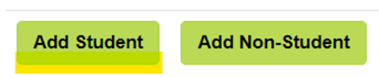
A list will populate, select the participant type of Student or State Officer of each person who will be attending, select T-shirt size, then click Save
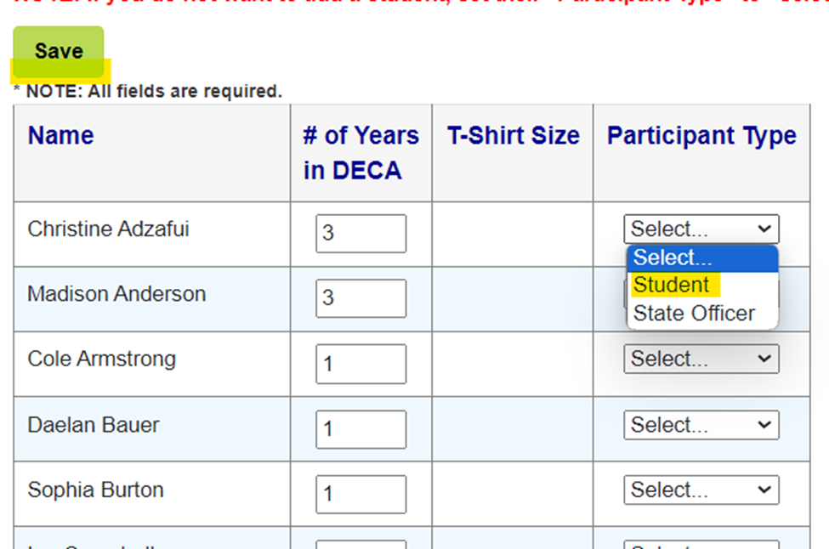

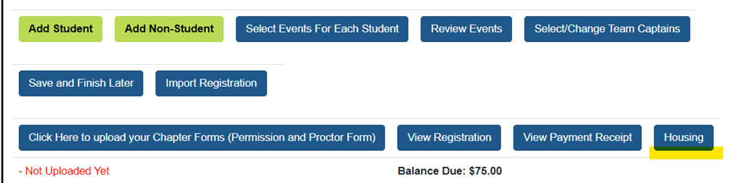
Then select Room Type, Room # and select the checkboxes next to the student names to be put in that room together and click on "Add To Room"
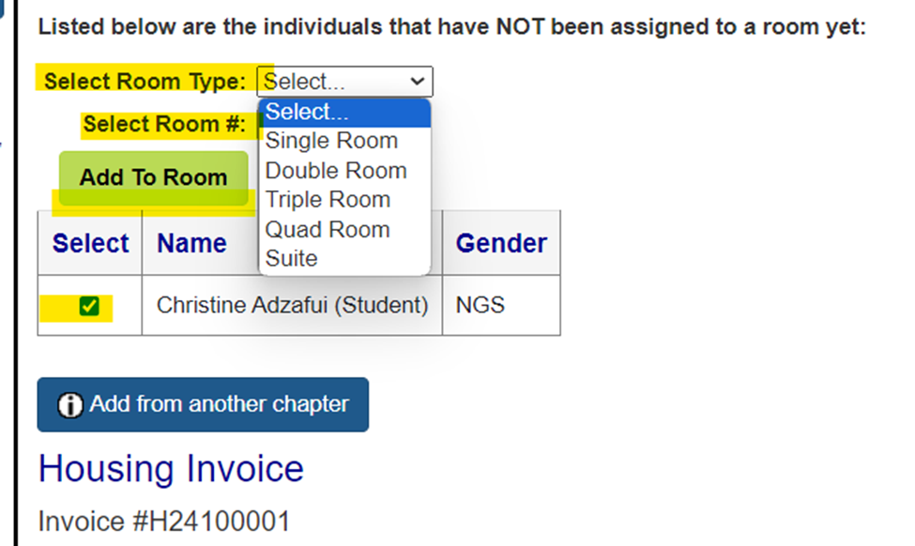
Continue to add until all students have been assigned to a room
You will use this process to add “non students” which include advisors and chaperones.
After you have registered all participants and submit registration, you will receive an invoice for registration and an invoice for housing. Use these invoices to process for payment.
- Other Required Forms
- The Chapter Permission and Test Proctor Forms are required with your registration and are also due Monday, February 5. These will be uploaded on the registration site under Chapter Forms. This needs to be one document/PDF.
- The Conduct/Procedures Code form and Medical Release form are to be filled out and retained by the chapter advisor.

If you have any questions or concerns, please contact Mary Janssen at 402-660-6506 mary.janssen@nebraska.gov or Maggie Schneider at 402.320.7796 or email maggie.schneider@nebraska.gov.

Competitive Events Code and Abbreviations
Individual Series Events
*1st-year DECA members ONLY

Principles of Business Management and Administration PBM

Principles of Finance PFN
Principles of Hospitality and Tourism PHT
Principles of Marketing PMK
Accounting Applications ACT
Apparel and Accessories Marketing AAM
Automotive Services Marketing ASM
Business Finance BFS
Business Services Marketing BSM
Entrepreneurship Series ENT
Food Marketing FMS
Hotel and Lodging Management HLM
Human Resource Management HRM
Marketing Communications MCS
Personal Financial Literacy PFL
Quick Serve Restaurant Management QSRM
Restaurant and Food Service Management RFSM
Retail Merchandising Series RMS
Sports and Entertainment Marketing SEM
Team Decision Making Events
Business Law and Ethics Team Decision Making Event BLTDM
Buying and Merchandising Team Decision Making Event BTDM
Entrepreneurship Team Decision Making Event ETDM
Financial Services Team Decision Making Event FTDM
Hospitality Services Team Decision Making Event HTDM
Marketing Management Team Decision Making MTDM
Sports & Entertainment Marketing Team Decision Making Event STDM
Travel & Tourism Marketing Team Decision Making Event TTDM
Business Operations Research Events
Business Services Operations Research BOR
Buying and Merchandising Operations Research BMOR
Finance Operations Research FOR
Hospitality and Tourism Operations Research HTOR
Sports and Entertainment Marketing Operations Research SEOR
Project Management Events
Business Solutions Project PMBS
Career Development Project PMCO
Community Awareness Project PMCA
Community Giving Project PMCG
Financial Literacy Project PMFL
Sales Project PMSP
Entrepreneurship Events
Innovation Plan EIP
Start-Up Business Plan ESB
Independent Business Plan EIB
International Business Plan Event IBP
Business Growth Plan EBG
Franchise Business Plan EFB
Integrated Marketing Campaign Events
Integrated Marketing Campaign – Event IMCE
Integrated Marketing Campaign – Product IMCP
Integrated Marketing Campaign – Service IMCS
Professional Selling Events and Consulting Events
Financial Consulting FCE
Hospitality and Tourism Professional Selling HTPS
Professional Selling PSE
AI in Competitive Events:
Please see this article from DECA Inc. pertaining to the use of AI within competitive events.
https://www.decadirect.org/articles/deca-competitive-events-use-of-ai

PRE-CONFERENCE ONLINE TESTING PROCEDURES
Tests are taken before the state conference with a proctor designated by the school. Students take the test online at a designated site through the DLG testing site.

Proctors for the exams must meet all of the following criteria:
- Minimum of 18 years old on the day of testing.
- Not a DECA Advisor or teacher within the department sponsoring the exam.
- Not a student within the sponsoring department at any time during the current academic year.
- Not a current examinee.
- Physically capable of observing activities throughout the testing site.
- Able to be present during the entire testing period and willing to actively supervise the exam process throughout the entire time.
- Willing to enforce all policies and procedures for testing.

Examinees are allowed:
- Use of hand calculators.
- Use of scratch paper. (NOTE: Scratch paper is to be collected and destroyed at the conclusion of testing.)

Examinees are not allowed:
- References or resources of any kind.
- Use of other computer programs while logged in to the DLG Web Portal.
- Communication with other students or the test administrator.
- To record in any manner any element of the exam.

Proctor registration form:
This will be submitted on the chapter registration site.

Additional new information from DLG regarding AI use
DLG discovered an issue with online testing and AI. Students downloaded an AI Chrome extension which allowed students to view the answers to test questions as they were taking the online exam. When students use the AI extension, it does trigger the move-away feature on the online testing site. As a preventative action, DLG has shortened the time for the move-away feature to log students out of the system, which has currently resolved the issue.
DLG plans to schedule a few webinars, in early January, for end users as to what to look for, what proctors need to know, the best setup for their testing sites, and how to prevent the usage of AI products, etc.
As you are preparing to administer online exams for competitive events, please make sure proctors are aware of the potential of these AI tools. Proctors will need to be even more intentional in moving around the room and checking students' computers. If students are triggering the move-away feature, they need to verify the reasoning before resetting the exam.
If you have any specific questions for DLG, please contact Shannon at shannon@registermychapter.com.

GENERAL CONFERENCE INFORMATION

Conduct Code/Procedures Forms
Code of Conduct and Procedures Forms must be completed, signed by all parties, and brought to the conference by the local advisor. It is the responsibility of the local advisor to verify these and assure that students understand their responsibilities as outlined in the forms. Please double-check the forms for completeness and appropriate signatures. In the case of any violations, school officials will be notified. The local advisor will be notified of disciplinary matters involving students. Please cross-reference the registration forms with your chapter rosters. Everyone you are registering must be a paid member of State and International DECA. Medical release forms are not required, but you may want to use the sample form available in the download section of the web site.

Conference Badges
Students must wear their conference badges at all activities, including tests, competitive events, workshops, entertainment programs and the dance. Badges must be worn on the upper torso so they are visible. Conference participants will be disqualified from competition if they allow others to wear their name badge.

Dress Code
From the opening session until the Grand Awards Session, students, advisors, and adult sponsors agree to adhere to the following Dress Code requirements.

Business representatives, press personnel, hotel staff, and special guests will be in attendance throughout the conference. Members and advisors are the organization’s best ambassadors and are urged to exhibit a professional business image at all times, whether in conduct or attire.

Examples include:
Blazer/business suit with dress blouse or
Skirt or dress slacks with dress blouse or dress sweater or
Business dress and
Closed-toe Dress shoes and stockings (no tennis shoes or flip-flop sandals)
Business suit with collared dress shirt and necktie or
Sport coat/dress slacks, collared shirt and necktie and
Dress shoes and socks (no tennis shoes or flip-flop sandals)

Billing/Incidentals
The hotel(s) will pre-package keys and will attempt to place each school's entire delegation on one floor. If you register for a triple room, this may mean three people - one king size bed. You may request rollaways at the prevailing rental charge. Inform your students in advance! An advisor from each school will check-in the entire chapter.
Each school's advisor is responsible for local and long-distance phone charges, if any. Phone charges must be paid at check-out time. Room service is discouraged. If used, payment upon delivery will be expected. Room service charges will not be added to the room account. All meals and snacks in the restaurants will be paid in cash and not added to the room account.

Bus Parking
Prior arrangements for parking of buses may be made through the Lincoln Transportation Service by calling Startran at 402/476-1234, 710 J Street. Advanced reservations are suggested. There is no bus parking at the Cornhusker Marriott or the overflow properties. Self-parking for school vans is available at the Cornhusker Marriott. If valet parking is required, arrangements can be made through the bell staff. Parking charges are the first hour free and $1.00 each additional hour or $9.00 for 10-24 hours in the two garages adjacent to the Cornhusker Marriott Hotel. Charges subject to change. Parking charges for the Embassy Suites are $9.00 per day.

Hotel Security/Damage Reports
Advise your students that:
- Deadbolt locks SHOULD NOT BE USED for the purpose of keeping doors open. They break easily and are very expensive.
- Connecting video gaming systems to the TV are prohibited. These systems will break the TVs and the student will be assessed a minimum $250 fine.
- Putting materials or written messages on room windows is prohibited.
- Food deliveries will be accepted only in the lobby. Students will pick up and pay at that time.
- Any damage will be reported to the school administration and charged to the local chapter.

Reservation Deadlines
Reservations will be made for arrival on the first day of the conference and will be held until 6:00 p.m. unless the Front Office is notified of guaranteed arrival (cost of one night’s lodging). Any arrivals after 6:00 p.m. should be noted on the Housing List. Please return all reservations directly to the hotel. It is important that reservations are accurate and that all checks be made payable to the Lincoln Marriott Cornhusker Hotel (or the overflow property). The Lincoln Marriott Cornhusker Hotel will send a Letter of Confirmation. Contact them if you have questions.

Arrival-Cornhusker Marriott
Students are to proceed to the exhibit (atrium) area with their luggage and advisors should go to the Front Desk to check-in. The keys will be in envelopes with names and room numbers to be given to the advisor to distribute to the students. A maximum of two keys per room will be issued. There will be a $1 fee for replacement of lost keys. Please advise students of this.

While in the Hotel(s)
Advisors are responsible for the conduct of their students while at the hotel(s) and will be held accountable for any damages incurred. A full report will be made to the home, school officials and parents of any student violating any laws or conference regulations. Students must not be outside of their room past the established curfew.

Departure
Make sure all incidental charges have been paid by your students before you check out. Check-out lines will not be held up to locate a student. Although charges can be paid prior to actual departure, the itemized bill showing the charge and payment cannot be given as receipt of payment until departure.

Competitive Events Notes
Simple, standard calculators will be allowed in event preparation. Participants must provide their own calculators. They may not borrow each other's during the competitions! BLANK note cards or notepaper is allowed in the events. Bringing two or three cards or sheets of paper for the judged events is a good idea. Phones are NOT allowed to be used as a calculator.

**ALL TEAM EVENTS WILL COMPETE IN TWO ROLE PLAYS – THURSDAY AND FRIDAY. No finals.

Written Project Events
Written projects are to be submitted ELECTRONICALLY before the state conference. Presentations will be done both Thursday and Friday. A detailed schedule will be sent out prior to the conference. Save each project as a PDF file, making sure that the signed written statement of assurances is added as the first page of each file. The file titles should be titles Event Acronym, Chapter Abbreviation, Last Name Last Name Last Name.pdf, as follows:
PMCA MS Janssen Schneider Talkington.pdf
Email to Mary Janssen mary.janssen@nebraska.gov and Maggie Schneider (maggie.schneider@nebraska.gov) no later than February 5, 2024.
**The only format accepted is PDF. The written statement of assurances needs to be the first page of the PDF document. At state we will print off one color copy for each panel of judges. If your project advances to ICDC, you are still required to submit those projects at ICDC in an official DECA portfolio.

If students are registered for a roleplay and a write event, they must attend and compete in BOTH. If they fail to show up for one, they are subject to total disqualification for the conference.

Judges
Quality competitive events require an adequate number of qualified judges. It is vital for all advisors to take personal ownership in finding judges. If you have judges for SCDC, please use the form and link to let us know! You will also be assigned a competitive event area for which you need to recruit judges. If we do not have your judges on file and confirmed through our state advisor, they will not be permitted to judge at State. You are NOT permitted to bring judges to conference without communicating with the state advisor. Rylee Turner, our judges coordinator, will contact them and provide exact details. Time commitments for judges are:

Role Play and Written Event Judges Thursday, March 14 4:00-9:30 pm
Friday, March 15 8:00 am.-2:00 pm

Dinner is provided on Thursday, breakfast and lunch are provided for judges on Friday.

Chapter Highlight Video-General Sessions
Special video productions featuring photos of local chapter members engaged in chapter activities throughout the year will be developed and presented throughout the general sessions of the conference. Students are disappointed when their chapter is not shown. Only the local chapter advisor(s) can provide the needed photos. Please don't disappoint your students. We will try to use as many pictures as we can. Only horizontally framed photos can be used. We will send more information out about this as it gets closer.

Non-Registered/Uninvited Guests
Please talk with your students about the problem of uninvited guests. Make sure they understand that they may be disqualified for “inviting” non-registered individuals to the conference site or giving their name badge to someone who is not a conference participant. Any major problems we have had at past conferences were related to individuals who were not actually a part of the conference. We do not want this to happen at our most important state DECA event of the year!

Special Guests
The Grand Awards program will begin at 8:00pm Friday night. We encourage you to invite one or two administrators, counselors, and other important DECA supporters. This is a tremendous public relations tool for Nebraska DECA and your program! Please let us know if you have additional guests by March 4, 2024 so we can plan for chairs. We will send a reminder out.

State Officer Candidate Booths
State Officer Candidate booths will be open Thursday, March 14, 9:00am-9:00pm and Friday, March 15,
8:00am-1:00pm. Encourage all your chapter members attending, but especially your voting delegates, to stop by the booths for information about each candidate. Set up will start at 8 am on Thursday for candidates.

Exhibitors
Exhibitors including Business Partners, colleges, universities, and fundraising companies will be set up on Thursday, March 14. All chapter advisors, sponsors, and members are encouraged to stop by the booths.

DECA Dance-Thursday Evening
A dance will be held Thursday evening, March 14 from 10:30-11:30 pm. Please advise your students that inappropriate behavior or attire of any kind will result in removal of the violator from the dance, contact of the local advisor and/or school administration and possible expulsion from the conference. The dance will be stopped at the first sign of any dangerous or inappropriate conduct. It is expected that one advisor or chaperone from each chapter is present at the dance.
Nebraska DECA State Career Development Conference Tentative Agenda – 2024

Thursday, March 14, 2024
Exhibit Set-Up 8:00 a.m. Atrium-1st Level
Campaign Booth Set-Up 8:00 a.m. Atrium-1st Level

Conference Registration 8:30-9:30 a.m. Conference Center-Lower Level

Advisor Briefing 9:30-9:45 a.m. Conference Center-Lower Level

Campaigning 9:00 a.m.-9:00 p.m. Atrium-1st Level

Chapter Meetings 9:45-10:30 a.m. Assigned Rooms

Opening General Session 10:40 a.m.-12:00 p.m. Grand Ballroom

Event Directors/Chairpersons Briefing Directly following opening session Grand Ballroom

Written Event Briefings 1:00-1:30 p.m. Grand Ballroom

Voting Delegates/Candidates Briefing & Speeches 1:30-2:30 p.m. Yankee Hill III

Competitive Events Briefing 3:15-3:45 p.m. Assigned Rooms

Competitive Events 4:00-9:30 p.m. Assigned Rooms

Leadership on Parade/Candidates Meetings 9:30-10:00 p.m. Grand Ballroom/Atrium

DECA Dance 10:30-11:30 p.m. Grand Ballroom

Curfew Midnight

Friday, March 15, 2024
Campaigning Booths 8:00 a.m.-1:00 p.m. Atrium

Competitive Events 8:00 a.m.- 2:00 pm Assigned Rooms

Question & Answer Session 2:00-3:30 p.m. Yankee Hill III
-Voting Delegates and Officer Candidates

Workshops/Tours 11:00 am-5:00 p.m. Various Locations
*Tentative, will provide details later

Election Session 4:30-5:30 p.m. Yankee Hill III

Grand Awards Session 8:00-10:00 p.m. Grand Ballroom

Curfew Midnight

Checklist for Advisors
Keys to Achieving Conference Success

Maintaining a positive and professional image for Nebraska DECA and your local chapter is a primary concern during the State Career Development Conference. Appropriate business etiquette, dress, and behavior are required throughout the conference. We need your assistance to create this positive image. The following items and suggestions will help you and your students have a fun & educational conference.

- Conduct/Procedures Agreement. Don't assume that they have read this; cover it point by point so your expectations and those of Nebraska DECA are very clear. Be positive, but forceful with expectations.

- Student contact. Have your students check-in with you at least 3 times each day.

- Establish a message center. This should be your room or that of one of your other sponsors.

- Stress curfew. Curfew is for EVERYONE. Food delivery, filling ice buckets, buying pop, or "just talking with my friends" are not acceptable reasons for being out of their rooms after curfew.

- Sit with your students. This creates a “team spirit” and provides better control at sessions.

- Be visible. Drop in and check on your students when you have free time. "Count heads" to see if they are going to the scheduled activities.

- Dress code. Stress wearing businesslike attire at all conference activities. We allow jeans/casual pants for social events such as dances, but professional attire and conduct is required at all other times.

- Pencils/pens, paper/note cards, calculators. All students should plan to bring these items to all events.

- Name Badges. Name badges are to be worn on the shirt/blouse/coat, not on slacks or jeans.

- Hotel damages/conduct problems. Damages to the hotel will be billed directly to the principal of the school with a listing of the occupants of the room, the advisor's name, and the exact damage and a bill for the damage. Violations of the conduct code will be dealt with immediately.

- Voting delegate responsibilities. Review these with your delegates carefully. All voting delegates are required to attend sessions as listed in the conference program. These include, but are not limited to:
Voting Delegate briefing /Speeches session Question and Answer forum Voting session(s)

- Awards ceremonies. Top 3 in each test and role play are recognized on screen and certificates will be placed in take-home packets. Grand Awards–Top 8 receive medallions, top 3 Individual Series Events, and top 2 Written Events receive trophies or plaques.

- Officer candidates. Review campaign guidelines with your candidates carefully. Remember, you as an advisor are not to actively campaign for your student(s).

- Alumni assistants. We welcome alumni to help with the conference. They must contact you for approval. You should then call us with the names and addresses.

Factors for Selecting Participants
The annual Career Development Conference is designed to be a professional, educational experience for both advisors and students. As such, businesslike attitudes and behaviors by both students and advisors are critical.

The competitive events, elections, workshops and keynote speakers are provided as an opportunity for students to showcase their skills and knowledge while presenting the image of their local and state organization to judges, parents, administrators, and hotel staff. Remember that attendance at any DECA function should be considered a privilege and an honor. Your assistance in promoting it in this manner will serve the state organization and your local school in the best possible way. By carefully considering those students who will be allowed to attend the State CDC, you will help make everyone's job easier. The following selection factors are recommended by the Nebraska DECA Board of Directors:
Recommended Selection Criteria

- Attendance and participation in area competitive events conferences such as the All-Metro Conference, Lincoln, or Greater Nebraska area competitions.

- Attendance and participation in your own local competition.

- Required participation in a specified number of pre-conference work/practice sessions. (Example: Attending 5 out of 10 scheduled sessions)

- Approval by the student's teachers/the administration/guidance counselor.

- Payment in full of all debts owed by the student to the local chapter.
- Meeting or exceeding a minimum number of points in a point system based on activities sponsored by the local chapter. This is an indication of personal responsibility.

- Approval/recommendation by the local advisor(s).

- Proven preparation for the specific occupational area in which the student will be competing. Examples: Checking out related material to study, completion of sample tests, and participation in role-playing sessions.

- Advance meetings with parents/guardians to cover timelier, rules, and conduct expected during the conference.

- Completion of all forms by the deadline date accurately and completely.

- Reminder to students that out-of-pocket expenses for meals will be approximately $40-$50 for meals and snacks depending on the needs of the students.

Recommended Procedures for Local Advisors
You, the local advisor, are the foundation for maintaining Nebraska DECA’s image. Please observe the following:

- No student should be allowed to drive a personal vehicle to the conference.

- Conduct frequent room checks and maintain personal contact with your students.

- Hold chapter meetings 15 minutes to ½ hour BEFORE the published curfew time each evening to:

  - Review program highlights and times of competitions, workshops, and general sessions
  - Discuss how the competitors felt about their performance in the competitive events
  - Remind everyone to organize their rooms and maintain a clean, professional atmosphere
  - Reinforce the Conduct/Procedures Code in a positive manner
  - Take attendance and establish that all your students are safe and ready for curfew check

- Curfew times should not be made flexible in any way. Curfews are for everyone!

- Room checks should be made at curfew to assure that all participants are in their assigned room.

- Ice chests/coolers should not be permitted. Ice and soft drink vending machines are on each floor.

- Make wake up calls in the morning or form “calling groups” to make sure that students are ready.

- Inform students prior to and during the conference of the repercussions of damaging hotel property.

- Stress that business attire is mandatory for all competitive events, workshops, and general sessions.

- Require business attire for the Grand Awards program.

- Stress the importance of always wearing their conference name badges on their shirt, blouse or jacket, not on slacks. Re-emphasize that replacement of lost badges costs $5.

- Remind students to bring adequate money to cover healthy meals and snacks during the conference.

- Stress that smoking, gambling, or the possession of alcohol or illegal narcotics IS PROHIBITED.

- Check each room before hotel departure to make sure that no damage has been done and that the room is reasonably clean.

- Collect all keys from students prior to checkout and turn them in to the front desk yourself.

Code of Ethics for Adult Advisors
For All Nebraska DECA Conferences

Professional conduct and appearance is a key component of the marketing education program.. At the Nebraska DECA Conference this phase of the instructional program becomes apparent. Since a good example is one method of teaching, and students participating in the Conference are impressionable, a set of guidelines was developed by the DECA Board of Directors for advisors.

The following are guidelines for all adult advisors in attendance at any Nebraska DECA Conference:

- Advisors shall conduct daily meetings with participants for progress reports, time schedules and other activities.

- Advisors shall keep an agenda for each student in order that they may be reached at any time during the Conference.

- Each advisor shall be responsible for seeing that participants adhere to all conduct practices and procedures.

- Advisors should check out at Conference Headquarters when leaving the hotel premises so we will know how to contact you in case of emergency.

- The rules as stated in the "Delegate Conduct/Procedures" form are called to your attention for review, and should govern the behavior of advisors as well as students.

Procedures for Handling Violations of the Conference
Conduct and Procedures Agreement or Advisor Code of Ethics

Any chapter whose members or advisor are not observing the conference curfew will be subject to disqualification from further conference participation and disqualification of competitive event participants. Conference rules and procedures apply to all chapters. Chapters or chapter members not adhering to the conference curfews or Conduct and Procedures Agreement will be subject to the following procedures:

- In the case of violations of any laws, hotel security and/or law enforcement authorities will be contacted to handle the situation; the local advisor and school administration will be notified as well.

- In the case of registered participants violating the Conduct and Procedures Agreement, but not violating local, state or national laws, the local chapter advisor AND school administration will be notified and requested to handle the situation according the Agreement and school policies.

- If appropriate action is not taken by the local advisor or administration, the DECA Board of Directors or a special committee appointed by the Board will convene to determine if the member(s) or entire chapter will be permitted to continue participation at the conference.

